**Assignment 1**

**Fundamentals of Programming**

Instructor: Sir Affan

Name: Syed Muhammad Ali Akbar

CMS: 477723

**Question 1:**

Write a C++ program to display factors of a number using for loops.

**Code 1:**

// Task 1

#include <iostream>

using namespace std;

int main()

{

    int num;

    cout<< "Enter any number to display its factors: "<<endl;

    cin>>num;

    for (int i = 1; i <= num; i++)

    {

        if (num%i==0)

        {

            cout<<i<<endl;

        }

    }

    return 0;

}

**Output 1:**

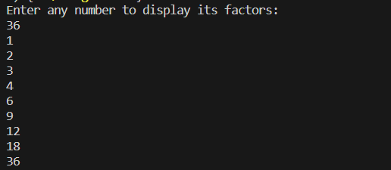

**Question 2:**

Write output to the following code.

#include<iostream>

int main() {

int x = 5;

int y = 10;

if (x == 5)

if (y == 10)

std::cout << "x is 5 and y is 10" << std::endl;

else

std::cout << "x is not 5" << std::endl;

return 0;

}

**Output 2:**

x is 5 and y is 10

**Question 3:**

Write a C++ program, take an integer value from user and check if it’s greater than 10 and less than equal to 20. Print 1 if yes and print 0 if no. Use appropriate datatype for output.

**Code 3 :**

//Task 3

#include <iostream>

using namespace std;

int main()

{

    int num;

    cout<< "Enter any number " <<endl;

    cin>>num;

    bool cn = true;

    if (num>10 && num<=20)

    {

        cn = true;

    }

    else

    {

        cn = false;

    }

    cout<<cn<<endl;

    return 0;

}

**Output 3 :**

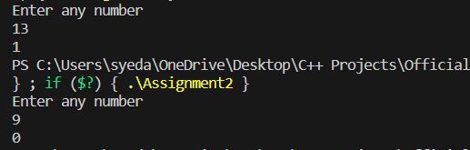

**Question 4:**

Write a C++ program that uses a while loop to find the largest prime number less than a given positive integer N. Your program should take the value of N as input from the user and then find the largest prime number less than or equal to N. You are not allowed to use any library or pre-existing functions to check for prime numbers.

**Code 4 :**

//Task 4

#include <iostream>

#include <cmath>

using namespace std;

int main()

{

    int N;

    cout<< "Enter any number(N) " <<endl;

    cin>>N;

    int num = 1;

    bool prime = true;

    int lp;

    while (num<=N)

    {

        int sqnum=sqrt(num);

        if (num==1)

        {

            prime = false;

        }

        else

        {

            for (int i = 2; i <= sqnum; i++)

            {

                if (num%i==0)

                {

                    prime = false;

                    break;

                }

                else

                {

                    prime = true;

                }

            }

        }

        if (prime)

        {

            lp=num;

        }

        num++;

    }

    cout<<"Largest prime number less than or equal to N is " <<lp<<endl;

    return 0;

}

**Output 4 :**

**Question 5:**

Write a C++ program, take two strings as input from user and check if both strings are equal or not. If they are equal, make them unequal by rotating string. e.g., Hello is turned into olleH etc.

**Code 5 :**

//Task 5

#include <iostream>

using namespace std;

int main()

{

    int i;

    bool equal = true;

    char str_1 [5];

    cout<<"Enter first 5 letter word: "<<endl;

    for(  i = 0; i <= 4; i++)

    {

        cin>>str_1[i];

    }

    char str_2[5];

    cout<<"Enter second 5 letter word: "<<endl;

    for(  i = 0; i <= 4; i++)

    {

        cin>>str_2[i];

    }

    for ( i = 0; i <= 4; i++)

    {

        if (str_1[i]!=str_2[i])

        {

            equal = false;

            break;

        }

        else

        {

            equal=true;

        }

    }

    if (equal)

    {

        for ( i = 0; i <=4 ; i++)

        {

            str_2[i]=str_1[4-i];

        }

    }

    cout<<"First word is: ";

    for (i = 0; i <= 4; i++)

    {

        cout<<str_1[i];

    }

    cout<<endl;

    cout<<"Second word is: ";

    for (i = 0; i <= 4; i++)

    {

        cout<<str_2[i];

    }

    return 0;

}

**Output 5) :**

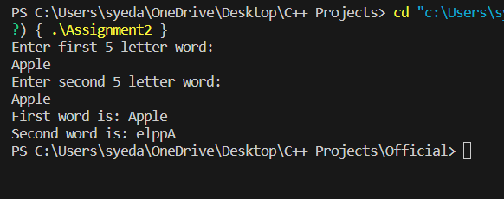

**Question 6:**

Perform division in C++ without / using for loops. You can use / only to display the results. Your dividend must be greater than divisor.

**Code 6) :**

//Task 6

#include <iostream>

using namespace std;

int main()

{

    int quo=0;

    int dividend;

    int divisor;

    cout<<"Enter Dividend"<<endl;

    cin>>dividend;

    cout<<"Enter Divisor"<<endl;

    cin>>divisor;

    if (dividend<=divisor)

    {

        cout<<"Dividend should be greater than divisor!!"<<endl;

    }

    else

    {

        for (int i = dividend; i > 0; i=i-divisor)

        {

            quo++;

        }

        cout<<dividend<<" / "<<divisor<<" = "<<quo<<endl;

    }

}

**Output 6 :**

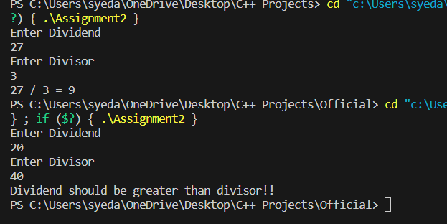

**Question 7 :-** Write a C++program for a string which may contain lowercase and uppercase characters. The task is to remove all duplicate characters from the string and find the resultant string.

**Code 7) :**

#include <iostream>

using namespace std;

int main()

{

    int n = 0;

    char str[5];

    char str_2[5];

    cout << "Enter any 5 letter string of characters" << endl;

    for (int i = 0; i < 5; i++)

    {

        cin >> str[i];

    }

    for (int i = 0; i < 5; i++)

    {

        bool duplicate = false;

        for (int j = 0; j < i; j++)

        {

            if (str[i] == str[j])

            {

                duplicate = true;

                break;

            }

        }

        if (!duplicate)

        {

            str_2[n] = str[i];

            n++;

        }

    }

    cout << "String without duplicates: ";

    for (int i = 0; i < n; i++)

    {

        cout << str_2[i];

    }

    return 0;

}

**Output 7 :**

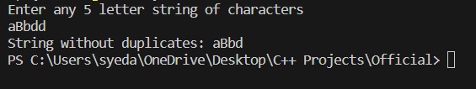

**Question 8 :-** Write a C++program for a string which may contain lowercase and uppercase characters. The task is to remove all duplicate characters from the string and find the resultant string.

**Code 8) :**

#include <iostream>

using namespace std;

int main()

{

    int arr [5]= {1,2,3,4,5};

    int new_elements;

    cout<<"Enter the number of new elements "<<endl;

    cin>>new_elements;

    int size = 5 + new_elements;

    int new_arr [size];

    for (int i = 0; i < 5; i++)

    {

        new_arr [i] = arr[i];

    }

    cout<<" Enter new elements "<<endl;

    for (int i = 5; i < size; i++)

    {

        cin>>new_arr[i];

    }

    cout<< "Updated array is: ";

    for (int i = 0; i < size; i++)

    {

        cout<<new_arr[i];

    }

    return 0;

}

**Output 8 :**

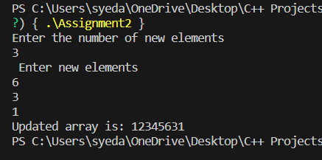

**Question 9 :-** Given an integer array and an integer X. Find if there’s a triplet in the array which sums up to the given integer X

**Code 9) :**

int main() {

    int X, size, sum = 0;

    bool result = false;

    cout << "Enter any number X to check whether a triplet in the array adds up to that number: " << endl;

    cin >> X;

    cout << "Enter size of array: " << endl;

    cin >> size;

    int arr[size];

    cout << "Enter elements of array" << endl;

    for (int i = 0; i < size; i++) {

        cin >> arr[i];

    }

    for (int i = 0; i < size - 2; i++)

    {

        for (int j = i + 1; j < size - 1; j++)

        {

            for (int k = j + 1; k < size; k++)

            {

                sum = arr[i] + arr[j] + arr[k];

                if (sum == X)

                {

                    result = true;

                    break;

                }

            }

            if (result==true)

            {

                break;

            }

        }

        if (result==true)

        {

            break;

        }

    }

    if (result)

    {

        cout << "Triplet was found that adds up to X" << endl;

    }

    else

    {

        cout << "No triplet was found that adds up to X" << endl;

    }

    return 0;

}

**Output 9 :**

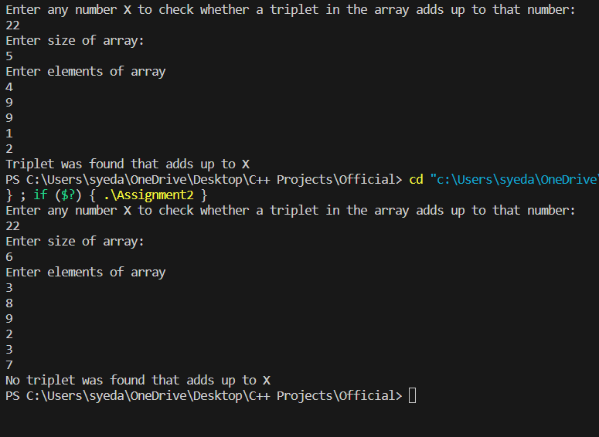

**Question 10 :-** Implement Bubble Sort on an array of 6 integers

**Code 10) :**

#include <iostream>

using namespace std;

int main()

{

    int org_arr [6];

    cout<<"Enter any 6 numbers: "<<endl;

    for (int i = 0; i < 6; i++)

    {

        cin>>org_arr [i];

    }

    cout<<"Original array: ";

    for (int i = 0; i < 6; i++)

    {

        cout<<org_arr[i];

    }

    cout<<endl;

    for (int i = 0; i < 5; i++)

    {

        for (int j = 0; j < 5-i ; j++)

        {

            if (org_arr[j]>org_arr[j+1])

            {

                int c = org_arr[j];

                org_arr [j] = org_arr [j+1];

                org_arr [j+1] = c;

            }

        }

    }

    cout<<"Sorted Array: ";

    for (int i = 0; i < 6; i++)

    {

        cout<<org_arr[i];

    }

    return 0;

}

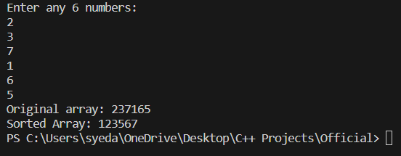**Output 10 :**